**EXPERIMENT - 7**

**AIM:**

To study the frequency response of Pre-Emphasis and De-Emphasis Circuit

**THEORY:**

In FM the interference (The noise) increases linearly with frequency, and the noise power in the receiver output is concentrated at higher frequency.

At the transmitter, weaker high frequency components of audio signal are boosted before modulation by pre-emphasis filter. At the receiver, the demodulator output passed through the De-emphasis filter, which undoes the pre-emphasis by attenuating the higher frequency components, where most of the noise is concentrated. The transfer functions of pre-emphasis and de-emphasis (PDE) are having exact opposite. Thus the process of pre-emphasis and d-emphasis leaves the desired signal untouched, but reduces the noise power considerably.

The PDE method of reduction is not limited just to FM broadcast; it is also used in audiotape recording and phonograph (analog) recording. We could also use PDE in AM broadcasting to improve the SNR, but in practice, this is not done for some reasons. That is output noise amplitude is constant with frequency, and does not vary as in FM. Hence deemphasis does yield such a dramatic improvement in AM as it does in FM.

The noise triangle shows, noise has a greater effect on the higher modulating frequencies than on the lower ones. Thus, if the higher frequencies were artificially boosted at the transmitter and correspondingly cut at the receiver, an improvement in noise immunity could be expected, there by increasing the signal-to-noise ratio. This boosting of the higher modulating frequencies, in accordance with a prearranged curve, is termed pre-emphasis, and the compensation at the receiver is called de-emphasis.

**CIRCUIT DIAGRAM:**

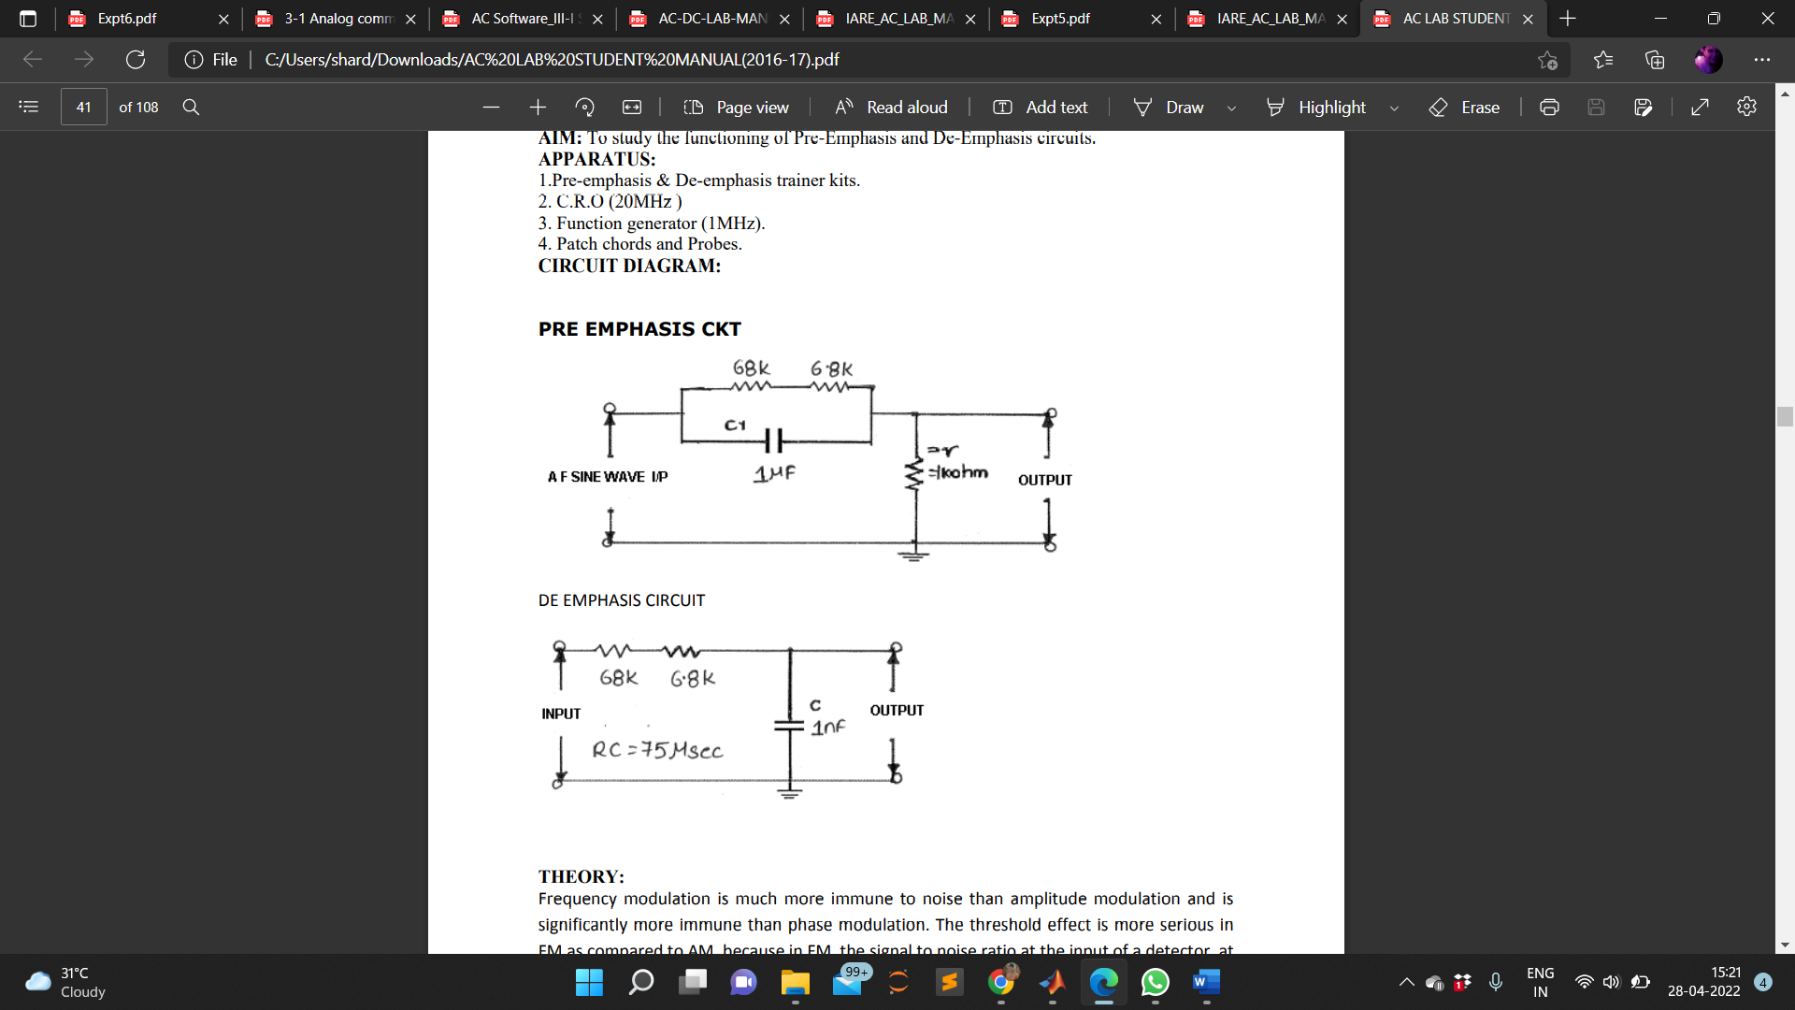

**MATLAB CODE:**

num_samples = 2^13; % no. of samples

fs=5000; % sampling frequency

Ts=1/fs; %Time range in terms of sampling frequency

fm1=20; %Message signal frequency 1

fm2=30; %Message signal frequency 2

fc=200; %carrier frequency

t=(0:num_samples-1)*Ts;

f=(-num_samples/2:num_samples/2-1)*fs/num_samples;

f_cutoff_pe=10;

Wn_pe=f_cutoff_pe/(fs/2);

[b_pe,a_pe]=butter(1,Wn_pe); %returns the transfer function coefficients of an 1st order lowpass digital Butterworth filter with normalized cutoff frequency Wn_pe

mt=sin(2*pi*fm1*t); %Modulating signal

figure(1);

subplot(211);

plot(t,mt);

axis([0 .6 min(mt)-1 max(mt)+1]);

grid on;title('Modulating Signal (Time Domain)');

Mf=fftshift(abs(fft(mt))); %rearranges a Fourier transform by shifting the zero-frequency component to the center of the array

subplot(212);

plot(f,Mf);

grid on;axis([-50 50 0 max(Mf)+100]);

title('Modulating Signal (Frequency Domain)');

[H_pe,W]=freqz(a_pe,b_pe); %Returns a_pe complex frequency response for digital filter b_pe

figure(2);

subplot(211);

semilogx(W*pi*(fs/2),abs(H_pe),'m','linewidth',2) %Plots x and y coordinates using log scale on the values mentioned

xlabel('frequency');

ylabel('H_pe');

axis([0 fs/2 0 50]);

grid on;

xlabel('frequency');

ylabel('Amplitude');

title('Pre-emphasisFilter Magnitude Response');

[H_de,W]=freqz(b_pe,a_pe); %Returns a_pe complex frequency response for digital filter b_pe

subplot(212);

semilogx(W*pi*(fs/2),abs(H_de),'m','linewidth',2); %Plots x and y coordinates using log scale on the values mentioned

axis([0 fs/2 0 1]);

grid on;

xlabel('frequency');

ylabel('Amplitude');

title('De-emphasis Filter Magnitude Response');

**WAVEFORM OBTAINED:**

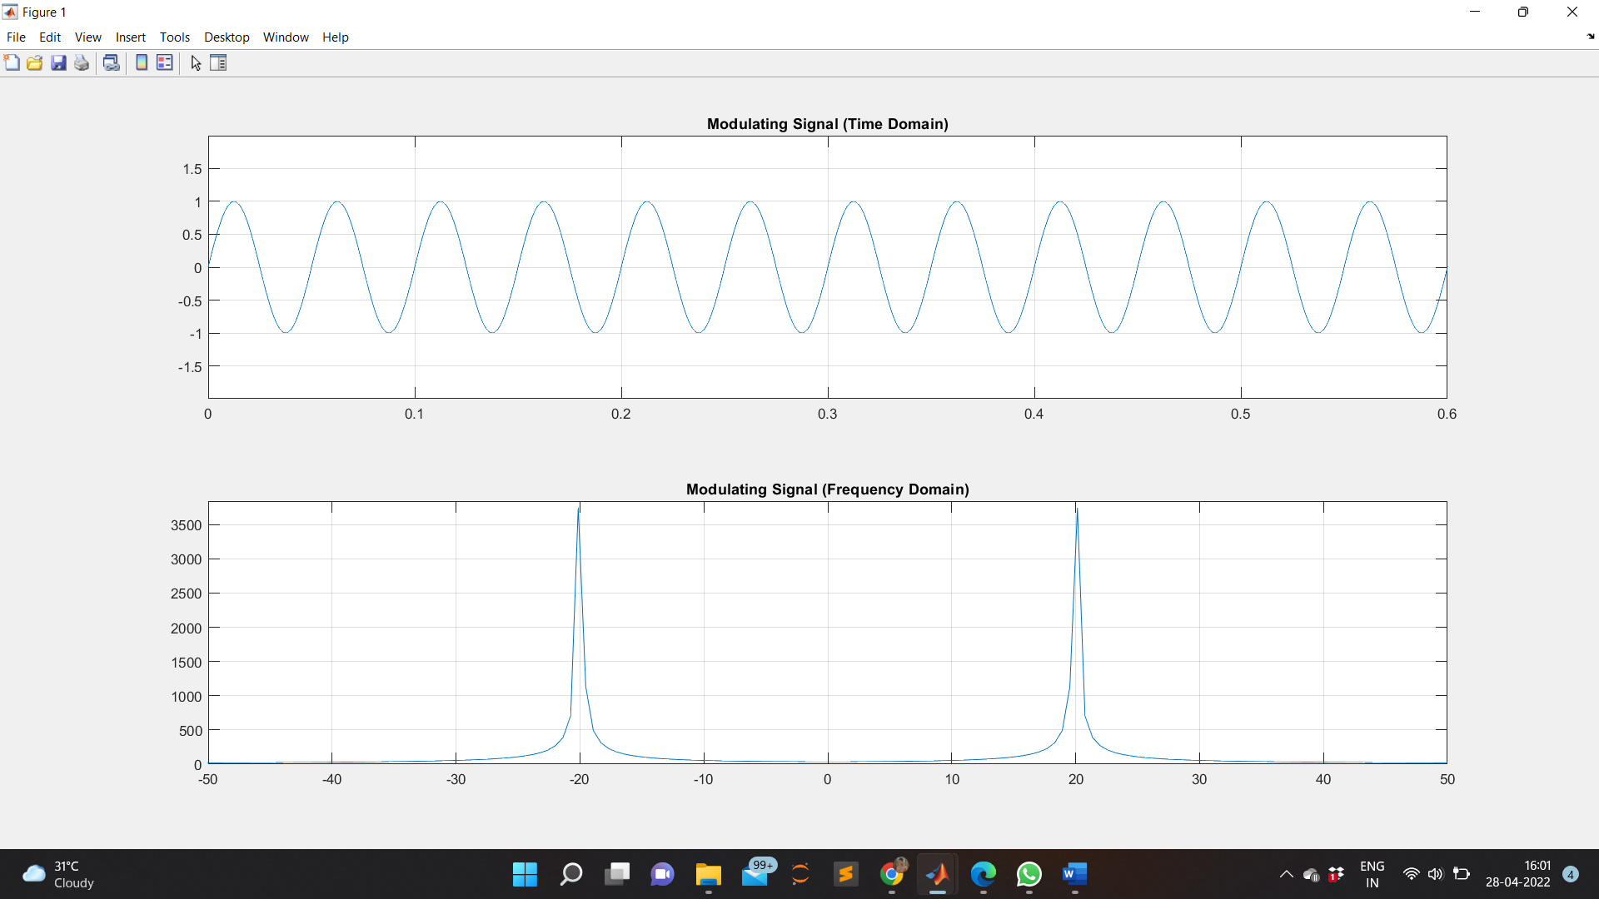

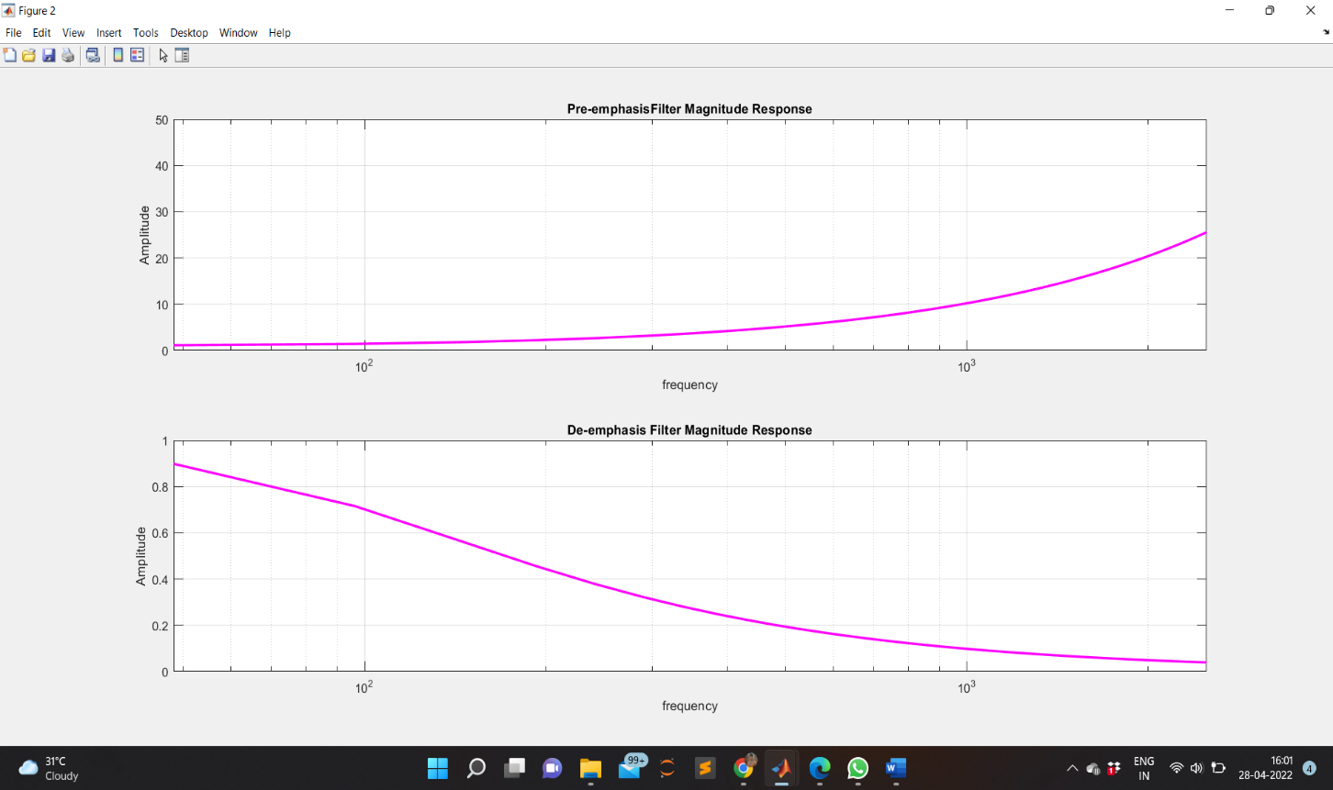

**RESULT:**

The frequency response of pre-emphasis and de-emphasis is studied, verified and the output waveforms are plotted.

**APPLICATIONS:**

Emphasis is commonly used in LP records and FM broadcasting. Pre-emphasis is employed in frequency modulation or phase modulation transmitters to equalize the modulating signal drive power in terms of deviation ratio. The receiver demodulation process includes a reciprocal network, called a de-emphasis network to restore the original signal power distribution.